

1

**COMSATS University Islamabad**

**COMPUTER NETWORKS**

**Fall 2023**

**LAB MID Assignment**

**SUBMITTED By:**

**Name:** Faizan Maqbool (SP22-BCS-022)

**Class:** BCS-4A

**SUBMITTED TO:**

SIR AHSAN

**Task 1**

**Build the Network and Configure Basic Device Settings**

**Step 1: Establish an addressing scheme.**

1. **First Subnet supporting 22 hosts (at R1).**

For 22 hosts, as the network is 192.168.22.0 and subnet mask is 255.255.255.0 (class C subnet

Mask). As we know 2^5 = 32 so we will need to keep 5 bits 0 in subnet mask and change 1st 3 bits

To 1 i.e.: 255.255.255.0 is actually 11111111.11111111.11111111.00000000 so in this 00000000

Portion, we will do subnetting i.e.: 11100000 where 111 is for network part and 00000 is for hosts.

1. **Record the Network ID of the first subnet.**

Network id: 192.168.34.0

1. **Record the first usable IP address, in the Addressing Table for R1 G0/0/1.**

192.168.34.1

1. **Record the usable IP’s and broadcast address.**

Usable IP’s: 192.168.34.1 -192.168.22.30

Broadcast address: 192.168.34.31

1. **Record the second subnet supporting 54 hosts (at R2) and do as above.**

For 54 hosts, as the network is 192.168.34.0 and subnet mask is 255.255.255.0 (class C subnet

Mask). As we know 2^6 = 64 so we will need to keep 6 bits 0 in subnet mask and change 1st 2 bits

To 1 i.e.: 255.255.255.0 is actually 11111111.11111111.11111111.00000000 so in this 00000000

Portion, we will do subnetting i.e.: 11000000 where 11 is for network part and 000000 is for hosts.Network id: 192.168.34.0

First usable IP address: 192.168.22.1

Usable IP’s: 192.168.22.1 -192.168.62.

Broadcast address: 192.168.22.63

**ROUTER 0 CONFIGURATION:**

Router>enable

Router#config t

Enter configuration commands, one per line. End with CNTL/Z.

Router(config)#hostname faizan1

faizan1 (config)#interface gig0/1

faizan1 (config-if)#ip address 192.168.22.1 255.255.255.224

faizan1 (config-if)#no shutdown

faizan1 (config-if)#

%LINK-5-CHANGED: Interface GigabitEthernet0/1, changed state to up

%LINEPROTO-5-UPDOWN: Line protocol on Interface GigabitEthernet0/1, changed state to up

faizan1 (config-if)#ip dhcp pool net1

faizan1 (dhcp-config)#network 192.168.22.0 255.255.255.224

faizan1 (dhcp-config)#default-router 192.168.22.1

faizan1 (dhcp-config)#exit

faizan1 (config)#interface gig0/0

faizan1 (config-if)#ip address 201.10.22.1 255.255.255.252

faizan1 (config-if)#no shutdown

faizan1 (config-if)#

%LINK-5-CHANGED: Interface GigabitEthernet0/0, changed state to up

faizan1 (config-if)#exit

faizan1 (config)#no ip domain-lookup

faizan1 (config)#exit

faizan1#

%SYS-5-CONFIG_I: Configured from console by console

faizan1#copy running-config startup-config

Destination filename [startup-config]?

Building configuration...

[OK]

faizan1#

**ROUTER 1 CONFIGURATION:**

Router>enable

Router#configure terminal

Enter configuration commands, one per line. End with CNTL/Z.

Router(config)#

Router(config)#hostname faizan2

faizan2 (config)#interface gig0/1

faizan2 (config-if)#ip address 192.168.22.1 255.255.255.128

faizan2 (config-if)#no shutdown

**faizan2config-if)#**

**%LINK-5-CHANGED: Interface GigabitEthernet0/1, changed state to up**

**%LINEPROTO-5-UPDOWN: Line protocol** on Interface GigabitEthernet0/1, changed state to up

faizan2 (config-if)#ip dhcp pool net2

faizan2 (dhcp-config)#network 192.168.22.0 255.255.255.128

faizan 2 (dhcp-config)#default-router 192.168.54.1

faizan2 (dhcp-config)#exit

faizan2 (config)#interface gig0/0

faizan2 (config-if)#ip address 201.10.22.2 255.255.255.252

faizan2 (config-if)#no shutdown

faizan2 (config-if)#

%LINK-5-CHANGED: Interface GigabitEthernet0/0, changed state to up

%LINEPROTO-5-UPDOWN: Line protocol on Interface GigabitEthernet0/0, changed state to up

faizan2 (config-if)#exit

faizan2 (config)#no ip domain-lookup

faizan2 (config)#exit

faizan2#

%SYS-5-CONFIG_I: Configured from console by console

faizan2#

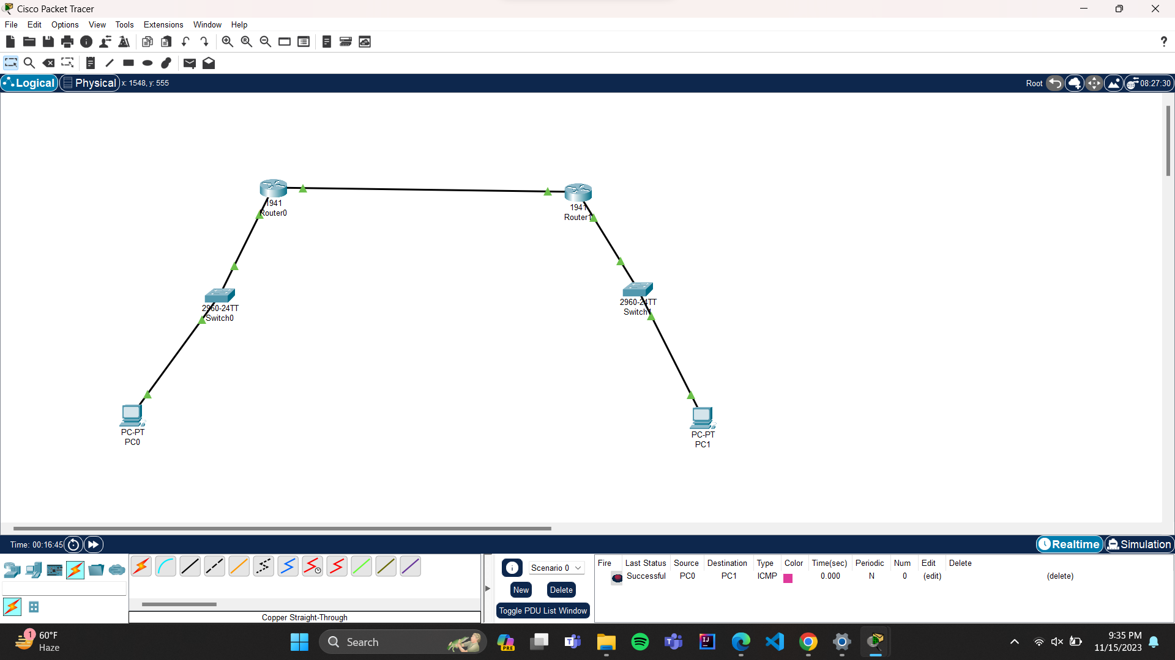

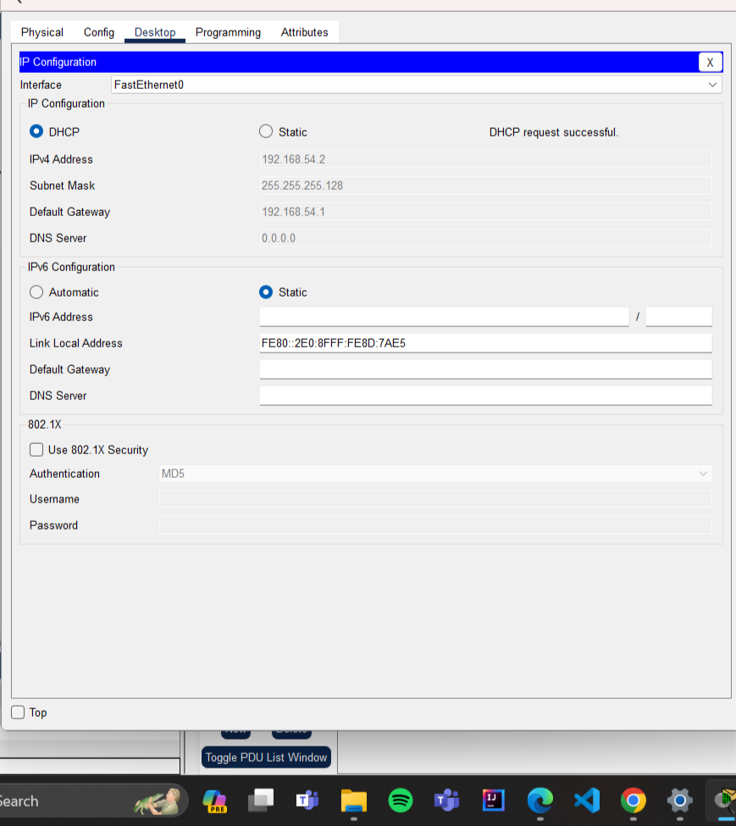

**LAB TASK 2:**

ROUTER:

Router>enable

Enter configuration commands, one per line. End with CNTL/Z.

Router(config)#hostname Faizan

Faizan (config)#enable?

enable

Faizan (config)#enable password faizan

Faizan (config-line)#password maqbool

Faizan (config-line)#login

Faizan (config-line)#line vty 0 4

Faizan (config-line)#password hahaha

Faizan (config-line)#exit

Faizan (config)#no ip domain-lookup

Faizan (config)#exit

Faizan #

%SYS-5-CONFIG_I: Configured from console by console

Faizan #telnetserver

Translating "telnetserver"

% Unknown command or computer name, or unable to find computer address

Faizan #config

Configuring from terminal, memory, or network [terminal]?

Enter configuration commands, one per line. End with CNTL/Z.

Faizan (config)#banner motd#UNAUTHORIZED ACCESS IS NOT ALLOWED!#

^

% Invalid input detected at '^' marker.

Faizan (config)#banner motd#UNAUTHORIZED ACCESS IS NOT ALLOWED#

^

% Invalid input detected at '^' marker.

Faizan (config)#banner motd #UNAUTHORIZED ACCESS IS NOT ALLOWED#

Faizan (config)#exit

Faizan #

%SYS-5-CONFIG_I: Configured from console by console

Bilal#copy running-config startup-config

Destination filename [startup-config]?

Building configuration...

[OK]

Faizan #

UNAUTHORIZED ACCESS IS NOT ALLOWED

User Access Verification

Password:

Password:

Faizan >enable

Password:

Faizan #config t

Enter configuration commands, one per line. End with CNTL/Z.

Faizan (config)#interface gig0/1

Faizan (config-if)#no sh

Faizan (config-if)#

%LINK-5-CHANGED: Interface GigabitEthernet0/1, changed state to up

%LINEPROTO-5-UPDOWN: Line protocol on Interface GigabitEthernet0/1, changed state to up

Faizan (config-if)#exit

Faizan (config)#interface gig0/1.10

Faizan (config-subif)#

%LINK-5-CHANGED: Interface GigabitEthernet0/1.10, changed state to up

%LINEPROTO-5-UPDOWN: Line protocol on Interface GigabitEthernet0/1.10, changed state to up

Faizan (config-subif)#encapsulation dot1q 10

Faizan (config-subif)#ip address 192.168.10.1 255.255.255.0

Faizan (config-subif)#exit

Faizan (config)#interface gig0/1.20

Faizan (config-subif)#

%LINK-5-CHANGED: Interface GigabitEthernet0/1.20, changed state to up

%LINEPROTO-5-UPDOWN: Line protocol on Interface GigabitEthernet0/1.20, changed state to up

Faizan (config-subif)#encapsulation dot1q 20

Faizan (config-subif)#ip address 192.168.20.1 255.255.255.0

Faizan (config-subif)#exit

Faizan (config)#

Faizan #

%SYS-5-CONFIG_I: Configured from console by console

**SWITCH 0:**

Faizan >enable

Switch#configure terminal

Enter configuration commands, one per line. End with CNTL/Z.

Faizan (config)#hostname Bilal1

Faizan1 (config)#no ip domain-lookup

Faizan1 (config)#exit

Faizan1#

%SYS-5-CONFIG_I: Configured from console by console

Faizan1#telnetserver

Translating "telnetserver"

% Unknown command or computer name, or unable to find computer address

Faizan1#config t

Enter configuration commands, one per line. End with CNTL/Z.

Faizan1 (config)#vlan 10

Faizan1 (config-vlan)#name Teacher

Faizan1 (config-vlan)#exit

Faizan1 (config)#vlan 20

Faizan1 (config-vlan)#name Student

Faizan1 (config-vlan)#exit

Faizan1 (config)#interface fa0/6

Faizan1 (config-if)#swi

Faizan1 (config-if)#switchport m

Faizan1 (config-if)#switchport mode a

Faizan1 (config-if)#switchport mode access

Faizan1 (config-if)#switchport access vlan 10

Faizan1 (config-if)#exit

Faizan1 (config)#

%LINK-3-UPDOWN: Interface FastEthernet0/1, changed state to down

%LINEPROTO-5-UPDOWN: Line protocol on Interface FastEthernet0/1, changed state to down

%LINK-5-CHANGED: Interface FastEthernet0/1, changed state to up

%LINEPROTO-5-UPDOWN: Line protocol on Interface FastEthernet0/1, changed state to up

%SPANTREE-2-RECV_PVID_ERR: Received 802.1Q BPDU on non trunk FastEthernet0/1 VLAN1.

%SPANTREE-2-BLOCK_PVID_LOCAL: Blocking FastEthernet0/1 on VLAN0001. Inconsistent port type.

Faizan1>enable

Faizan1#config t

%LINEPROTO-5-UPDOWN: Line protocol on Interface FastEthernet0/1, changed state to down

%LINEPROTO-5-UPDOWN: Line protocol on Interface FastEthernet0/1, changed state to up

Enter configuration commands, one per line. End with CNTL/Z.

Faizan1 (config)#interface fa0/1

Faizan1 (config-if)#switchport mode trunk

Faizan1 (config-if)#exit

Faizan1 (config)#

Faizan1 (config)#interface fa0/5

Faizan1 (config-if)#swi

Faizan1 (config-if)#switchport m

Faizan1 (config-if)#switchport mode tr

Faizan1 (config-if)#switchport mode trunk

Faizan1 (config-if)#exit

Faizan1 (config)#

%LINK-5-CHANGED: Interface FastEthernet0/5, changed state to up

|  |  |  |  |
| --- | --- | --- | --- |
|  |  |  |  |
|  |  |  |  |
|  |  |  |  |

%LINEPROTO-5-UPDOWN: Line protocol on Interface FastEthernet0/5, changed state to up

Faizan1 (config)#interface fa0/5

Faizan1 (config-if)#switchport mode trunk

Faizan1 (config-if)#do wr

Building configuration...

[OK]

Faizan1 (config-if)#

Faizan1 (config-if)#exit

Faizan1 (config)#

**SWITCH 2:**

Switch>enable

Switch#config t

Enter configuration commands, one per line. End with CNTL/Z.

Switch(config)#hostname Faizan2

Faizan2 (config)#no ip domain-lookup

Faizan2 (config)#vlan 10

Faizan2 (config-vlan)#name teacher

Faizan2 (config-vlan)#exit

Faizan2 (config)#vlan 20

Faizan2 (config-vlan)#name student

Faizan2 (config-vlan)#exit

Faizan2 (config)#interface fa0/18

Faizan2 (config-if)#switchport mode access

Faizan2 (config-if)#switchport access vlan 20

Faizan2 (config-if)#exit

Faizan2 (config)#

%LINK-3-UPDOWN: Interface FastEthernet0/1, changed state to down

%LINEPROTO-5-UPDOWN: Line protocol on Interface FastEthernet0/1, changed state to down

%LINK-5-CHANGED: Interface FastEthernet0/1, changed state to up

%LINEPROTO-5-UPDOWN: Line protocol on Interface FastEthernet0/1, changed state to up

Faizan2 (config)#interface fa0/1

Faizan2 (config-if)#switchport mode trunk

Faizan2 (config-if)#

%LINEPROTO-5-UPDOWN: Line protocol on Interface FastEthernet0/1, changed state to down

%LINEPROTO-5-UPDOWN: Line protocol on Interface FastEthernet0/1, changed state to up

Faizan2 (config-if)#exit

Faizan2 (config)#

IMAGES:



